To create react APP

https://codepen.io/manishvbn/pen/mEKvxY

1. Manually
2. React CLI

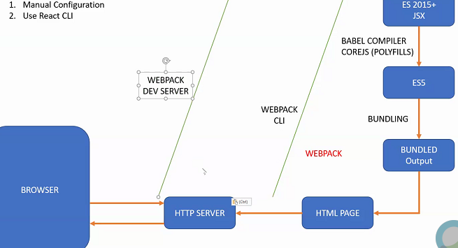

1. AutoFileName
2. ReactJS code snippet
3. vsCode-icons
4. npm install -g create-react-app (or create package.json and then make it local also)
5. npm list -g –depth=0
6. npm cache clean -force
7. nodevars
8. – **for specific version**
   1. Npx create-react-app (new project generate at the location where you fire it)
9. Create-react-app first-app
10. Npm run eject
11. To specify port and default browser create .env file in root folder and put below info
    1. PORT = 1234
    2. BROWSER=CHROME
12. React.strictmode to check good practice checks of react and bad part it shows in angular browser
13. Babeljs.io
14. Class syntax for component more used when we want stateful or container
15. Function syntax used when stateless or presentational component are required.
16. React Dev tools to see all loaded compoents
17. Redux dev tool extention for redux.
18. <https://medium.com/@luisvieira_gmr/building-large-scale-react-applications-in-a-monorepo-91cd4637c131>
19. CSS Modules compiler for CSS moduling
20. React.strictmode will run code twice in dev mode to check for best practices.
21. Deep copy with method can be done by using immutability helper library.
22. In class syntax of component we can access props and state in render method . in function component we cant access this keyword so we cant access state and props
23. Synthetic event objects are objects which are passed as event object by react on every browser. Example e.preventdefault will work on all browsers.
24. If some variable is used on state the changing that everytime calls render. So when you don’t use that variable in rendering area then use that variable outside state as local variable.
25. State can be shared through refs but we should not share state directly between components. Igf required it should be done by some method.
26. In react data is unidirectional so react does not allow controls to be modified and this is known as controlled controls. If you want to change the controls then you should implement either onchange event through which you can change the state or you should mark control as readonly.
27. Uncontrolled component state and ui are not in sync so we should always go ahead with controlled components.
28. To see the error handler without stack trace. Create build and run command http-server ./build
29. Hooks used to give power to function components like classes. Example function component can’t have state so state hook used to use state in function. Another example to write llifecycle events we can use effect hook.
30. Componentdid update get called whenever state or props modified.
31. For all hooks search for react hooks to be used in function. Hooks for functions available only after version 16 and not before that.
32. React router weuse for routing in react. npm install react-router-dom.
33. Switch in react is like router outlet in angular.
34. Use react bootstrap to use various controls available for react.
35. Higher order component(HOC) is a function which takes component and returns new component
36. For redux
    1. Npm I redux react-redux
37. MatchDispatchtoProps are used to connect actions to component and matchStateToProps is required to connect state to component.
38. WithRouter method calls component undercontext of router so it adds the router properties as a part of that functional component.
39. Rather than thunk we can use saga also in react. We have other middlewares also. Like observables or promises.